Christmas Eve Dinner

**Version: 2019.pre**

Menu:

* Pecan Smoked Prime Rib with Au Jus & Horseradish Sauce
* Pecan Smoked Turkey Breast with Au Jus-style Turkey gravy
* Purée of Yukon Gold Potatoes with Parmesan
* Roasted Brussels Spouts

Equipment:

* Multiple Roasting thermometers
* Roasting pans
* Carving knife
* Fat separator

Christmas Eve Schedule (2019 Plan):

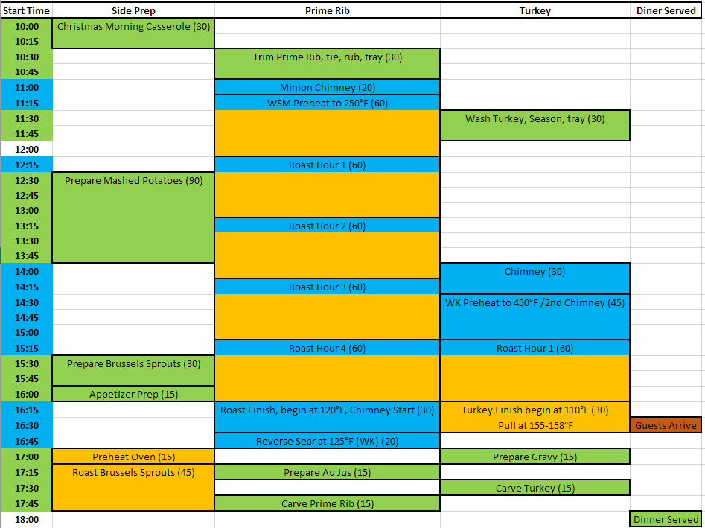

**Prime Rib Preparation – Up to four days before**

* Kosher Salt
* Freshly Ground Black Pepper
* Bone-in Prime Rib

Research:

<https://www.seriouseats.com/recipes/2009/12/perfect-prime-rib-beef-recipe.html>

<https://www.foodnetwork.com/shows/good-eats/videos/family-roast>

<https://youtu.be/P7_q87BEatI>

<https://youtu.be/tc9Eisi8ik0>

<https://amazingribs.com/tested-recipes/beef-and-bison-recipes/prime-rib-and-other-beef-roasts>

1. Order meat from a good butcher. You are looking for good marbling. I have seen suggestions for both the loin and chuck ends, so I have no specific recommendation. You want about 1 pound per person, each bone accounts for roughly 1.5 to 2.5 pounds, so order two bones for every three people. For 7 people that means we need 4.7 bones. In 2018, I ordered a 5-bone roast, which weighed 12.5 pounds, so each bone accounted for roughly 2.5 pounds—this was overkill for 7 guests for sure. In 2019 I ordered a 4-bone roast, 8.7 pounds, about 2.2 pounds per bone.
2. At pickup, request that the butcher cut the meat off the bones and then ties it back into place. When I picked up the roast at Whole Foods in 2018 & 2019, this was already done.
3. Rinse the roast and slice a cross-hatch pattern into the fat cap…don’t cut into the meat though. Or, preferably, trim as much fat as possible off the roast. It doesn’t baste the meat, and nobody will eat it, so the crust will be wasted…trim down to the meat and remove any hard fat especially, which won’t render anyway.
4. Season heavily with salt and place in refrigerator, uncovered, for up to four days in advance to air-dry/dry-brine the roast.

**Prime Rib Roasting**

* Previously air-dried roast
* Black pepper, garlic powder, fresh rosemary
* Carrots, Onions, Celery, Garlic for roasting pan
* ½ quart Beef Broth
* Merlot

1. Liberally apply 16-mesh black pepper, garlic powder, and rosemary to the roast. No additional salt is needed. If the surface is very dry, you can use mustard, olive oil, or Worcestershire sauce as a binder to help the seasoning stick.
2. Preheat pit to 250°F. Have a few chunks of pecan standing by.
   1. Approximate roasting time at 250°F: 1 hour per 1” of diameter
3. Prepare roasting pan by scattering carrots, onions, celery, rosemary and garlic in pan to create a “rack”. Add beef broth & Merlot to a depth of about 1”. This is just to keep things wet while waiting for drippings to take over.
4. Place a roasting thermometer in the very center of the roast and set the alarm as appropriate:
   1. Roast to 122°F. Carry over will add another 5 to 10°F.
      1. Rare: 120-125°F
      2. Medium Rare: 125-130°F (127-132°F according to Alton Brown)
      3. Medium: 130-135°F
5. Place on very hot grill (450-500°F) to sear for 5 minutes. Rotate ¼ turn and repeat to sear all sides.
6. After searing, prepare the au jus, carve, and serve.

**Au Jus Preparation**

* Pan drippings from roast
* flour

Research:

<https://youtu.be/36WY9NRxlE4>

1. Remove vegetables from drippings
2. Strain drippings into fat separator. Reserve both
3. Add ¼ cup of fat to a saucepan over medium-high heat.
4. Add a few teaspoons of flour into the fat and let cook for 3 minutes to get flour taste out.
5. Add pan drippings in, mixing or whisking constantly. Slowly add all of the drippings. You are not looking for a thick gravy, au jus is generally fairly thin,
6. Keep hot until ready to serve. This should be very hot when served, as it will help warm up the meat, which has likely cooled from carving and resting.

**Horseradish Sauce**

* 16 oz Sour Cream or Crème Fraiche
* 1 teaspoon Worcestershire Sauce
* 1 teaspoon Black Pepper
* 4 oz Prepared Horseradish
* 1 teaspoon Kosher Salt
* 2 Tablespoons Dijon Mustard
* 1 teaspoon Red Wine Vinegar
* 1 teaspoon Cayenne Pepper
* 1 Tablespoon Lemon Juice
* Fresh Chives

Research:

<https://youtu.be/jJkWhjfmkZM>

1. Combine all ingredients, refrigerate a few days to let flavors meld. Serve.

**Purée of Yukon Gold Potatoes with Parmesan**

* 5 pounds Yukon Gold potatoes, peeled, quartered, and rinsed
* 3 teaspoons kosher salt
* 2-1/4 cups whole milk
* 3/4 cup heavy cream
* 3/4 cup unsalted butter
* 1 cup fresh grated Parmigiano Reggiano
* Freshly ground black pepper

1. Put the quartered potatoes in a large saucepan with enough cold water to cover. Partially cover the pot and bring to a boil.
2. Uncover, add the salt, and reduce the heat to a gentle boil. Cook potatoes until tender, 20 minutes. Meanwhile, heat the milk and cream until hot, but do not boil.
3. Drain the potatoes in a colander, let sit for 15 minutes to dry and finish cooking.
4. Use a potato ricer, masher, or food mill to mash the potatoes.
5. Blend the butter, and Parmigiano into the potatoes. Gradually add the milk mixture until the purée is as soft and moist as you like.
6. Add salt and pepper to taste.
7. Keep warm in Crock-pot or similar. I typically simply put the pot of potatoes in boiling water.

**Roasted Brussels Spouts**

* 1.5 pounds Brussels sprouts
* 3 Tablespoons olive oil
* ¾ Teaspoon kosher salt
* ½ Teaspoon black pepper

From: <https://www.foodnetwork.com/recipes/ina-garten/roasted-brussels-sprouts-recipe2-1941953>

1. Preheat oven to 400°F
2. Cut off the brown ends of the sprouts and remove yellow leaves
3. Mix sprouts in a bowl with olive oil, salt, and pepper
4. Place on a baking sheet and roast for 35 to 40 minutes, until crisp on the outside and tender on the inside. Shake pan occasionally to brown all sides.
5. Sprinkle with additional kosher salt and serve.

**Freshly Prepared Horseradish**

* 4 to 6 ounces of fresh horseradish root
* Kosher salt
* 4 to 6 ounces white vinegar
* Water

<https://youtu.be/KEQWBY6P6Vs>

1. Have your ingredients, especially the vinegar ready to go.
2. Peel and chop the horseradish. Add to a food processor and process until finely chopped. WARNING: Do this in a well-ventilated area—the fumes from the horseradish can be oppressive.
3. After finely chopping the horseradish, start your timer and add the vinegar to limit the heat using the rough table below:
   1. 0 time: Mild
   2. 2 minutes: Medium
   3. 4 minutes: Hot
   4. 6 minutes: Good luck to you.
4. After adding the vinegar, continue to process in the food processor until the mixture is a thick, lumpy, creamy paste consistency.
5. Add water if you need to thin the mixture more.
6. Store in a jar in the refrigerator. Prepare this a few days ahead.

**Creamed Spinach**

* 3 pounds baby spinach
* 1 ¼ cups whole milk
* 1 cup heavy cream
* 1 small onion
* ¼ cup unsalted butter
* ¼ cup flour
* Nutmeg

Research:

From Mom

1. Heat milk and cream to warm.
2. Cook onion in butter until soft.
3. Whisk in flour and cook roux for 3 minutes.
4. Add the warm milk and cream, whisking constantly to ensure smoothness.
5. Simmer 3 to 4 minutes. Add salt, pepper, and nutmeg to taste.
6. Cream mixture can be made and stored if desired.
7. Wilt spinach in boiling water, drain and squeeze to remove excess water.
8. Coarsely chop the spinach and add to the warm cream mixture to coat.

**Revision History & Notes**

* 12/16/2018, ksb, created
  + Created initial release from input from Mom, Kenji Lopez-Alt, Alton Brown, and T-Roy.
  + Using reverse sear method based on Kenji and Alton’s information
  + Roast ordered online from Whole Foods. Reserved a 5-bone roast. At pickup the roast had already been cut from the bone and retied. 12.34 lbs.
  + Made homemade horseradish. Two good size pieces was too much for the small Cuisinart—use full size next time. Have an equal size portion of vinegar ready to go and don’t let it go too long. I used too little vinegar and the heat continued to intensify.
  + I made and applied the crust paste the morning before. We will see how well this works out. In the future I would make more and probably apply it just prior to roasting.
  + Crust was a bust. It burned and fell off when strings were cut.
  + Lots of smoke was generated during final sear…drippings fell into hot (empty) roasting pan and burned. See updated recipe to prevent this in the future.
  + Convection roasting at 200°F worked wonderfully. Meat was very tender, delicious, and perfectly cooked.
  + Carry over was 10°F exactly, even with roasting at 200 to 250°F. Meat was essentially between medium rare and medium with rise to 137°F.
  + Here is the cooking chart:
    - In at 13:30 at 44°F
    - 15:10 at 54°F (100 minutes)
    - 15:38 at 64°F (28 minutes)
    - 16:08 at 74°F (30 minutes)
    - 16:37 at 84°F (29 minutes)
    - 17:07 at 94°F (30 minutes)
    - 17:40 at 104°F (33 minutes) (raised oven temp to 225°F)
    - 18:16 at 114°F (36 minutes)
    - 18:57 at 124°F (41 minutes) (raised oven temp to 250°F)
    - 19:09 at 127°F (12 minutes)…(5:39 total cook time)
  + A 5-bone roast was way too much for 7 people. Could easily serve 10 to 12. 1-pound per person is a good estimate. Could probably go with 3 or 4 bones max.
* 12/20/2019
  + Ordered a four-bone roast this year. 8.67 pounds, $112
  + 48 hour dry brine. Added cross-hatch pattern to the fat cap.
  + Very little marbling. Grass-fed beef may not be the best choice.